**Networking Project**

**Info-3380**



**Submitted To:**Dr. Robert Houghton

Idaho State University

**Prepared by:**

Kishor Simkhada

12/7/2017

**Required Tool for the Project:**

**Tool 1: Install GNS 3 which is used for network simulation.**

The first picture is the picture for GNS 3. It is integrated with the Wireshark 3rd pic and Putty 4th pic. Wireshark is used for packet capturing.

**Tool 2: Install Virtual Box**

This is the used for creating the virtual environment and you can use the virtual operating system on it.

**Setting up Virtual box:**

**\*ISO image for the operating system is required**

**Step1:** After you install the virtual box go to new Name virtual box and select the desired operating system =>Next

**Step2:** Allocate memory and =>Next

**Step3:** Create Virtual disk=> Create=> Select VDI and =>Next

**Step4:** Dynamically allocated=> Specify the hard disk as needed and available>Create

**Step5:** Click on the operating system you just created and give the location of ISO image.

It will install the operating system on your virtual box.

**Installing GNS3:**

It is like the basic installation you have done before. It will install all the required software and file by its self that includes Wireshark, Putty, SolarWinds etc.

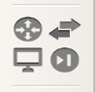**Adding the Cisco Router in GNS3:**

**Step1:** click on this icon at the bottom of the page you will see new application templet. Click on it.

**Step2:** Check First option =>OK

Then Check run ISO on Local Machine=>Next

Step 3: Provide the location of ISO Image=>Next=>Next=>Finish and Apply and OK

**Adding the Virtual Machine in GNS3:**

**Step1:** Again new application templet=> this time new VirtualBox virtual machine=>OK

Then run on Local Machine=> Next =>Finish

**Starting Project:**

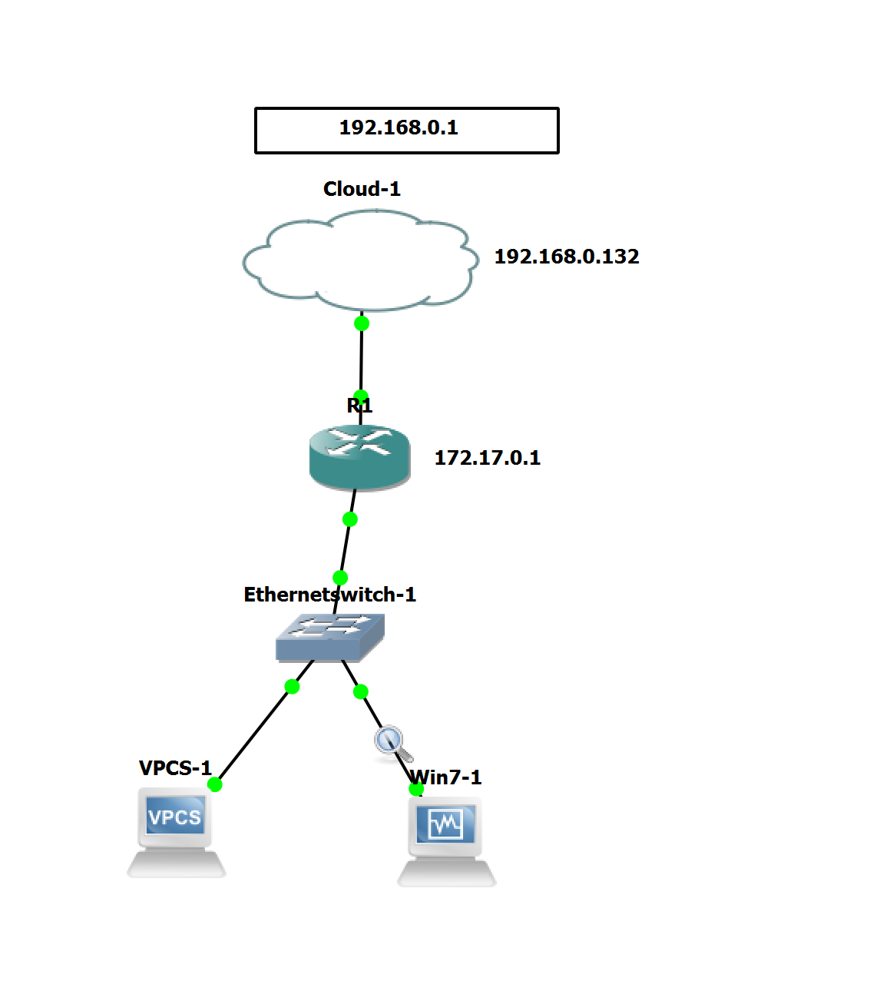

**Run Gns3 on administrator Mode**

**Creating new Project:**

**Step1:** File=> New Blank Project

**Step2:** Drag and drop all the component on the screen as shown in that image above.

**Step3:** Connect router with switch and cloud. Cloud will be fastethernet0/0 and switch will be fastethernet0/1.

Connect the VPCS and your Virtual operating as per your desire.

**Configuring Router:**

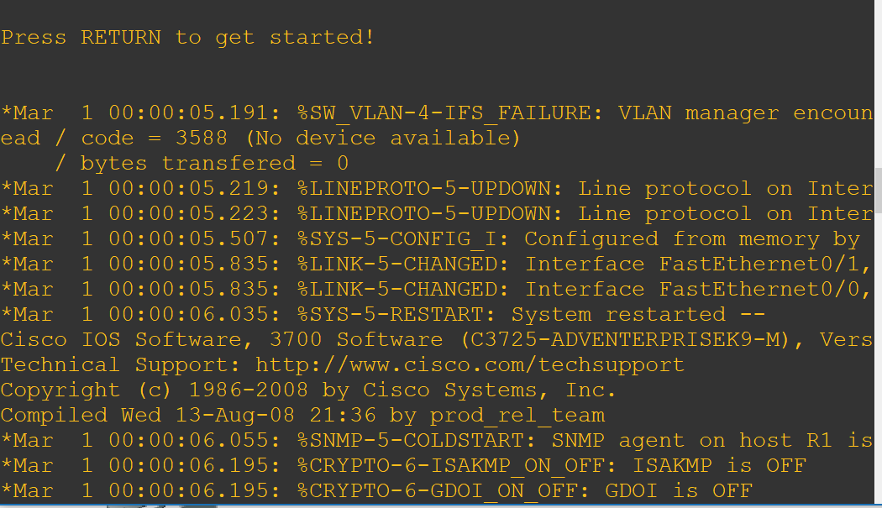After all the connection are made click on play and double click on router. Then,

You will see something like this

Full term

Conf t =>Configurating Terminal

Int => Interface

f0/0or f0/1 =>fastEthernet

shut =>shutdown

*Things inside () is just for explanation.

**Fastethernet0/0:**

Type the following configuration

Conf t

Int f0/0

Ip add dhcp

No shut (after this line you should get a ip from your physical router)

Exit

Ping 192.168.0.1(checking the connection)

(Defining the DNS Server this part is not necessary but can be helpful to check the connections)

Conf t ip name-server 192.168.0.1

Ip domain-lookup

Exit

(Now you can ping google)

*Before this line we have made the connection from our virtual router through the cloud to the physical router.

**Fastethernet0/1:**

(this is for making connection for the device below the router which will be Switch, VPCS, Win7 in this case

Conf t

Int f0/1

Ip add 172.17.0.1 255.255.255.0

No shut

Exit

(We have assigned the Static IP to f0/1 as we are already getting the dynamic from f0/0)

Our f0/0 is the Outside past of NAT and F0/1 is the Inside part so,

**Configuring NAT:**

Conf t

Int f0/0

Ip nat outside

Exit

Int f0/1

Ip nat inside

Access-list 1 permit 172.17.0.0 0.0.0.255

Ip nat inside Source list 1 int f0/0 overload

( We have set the IP nat, Now we need dhcp pool )

Ip dhcp pool 172.17.0.1/24(Range)

Network 172.17.0.1 255.255.255.0

Default-router 172.17.0.1

Dns-server 192.168.0.1

Exit

Exit

(We have successfully configured our router now you can chek the connection on your network)

How you can check the connection from VPCS and Virtual Box?

**VirtualBox:**

**Step1:** Run Cmd and type ipconfig/release (to release the lease)

**Step2:** Ipconfig/renew

**This should renew your lease**

**Now you should be able to ping to the internet and device in your net as well.**

**VPCS:**

**First,** Run the console and type

IP dhcp (to get the ip address)

And show ip

Which would look like:

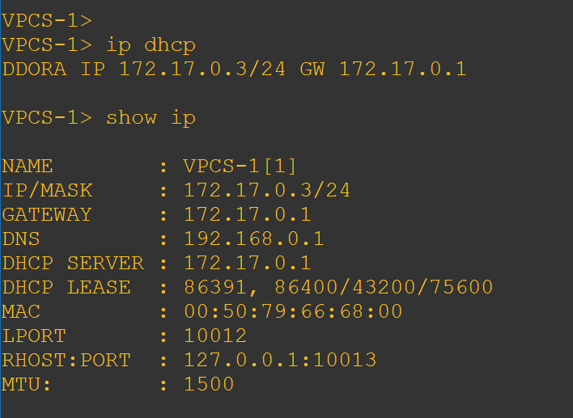

Thank you